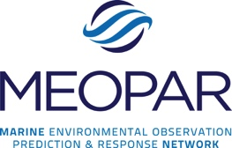

Resilient Coast: Liquid Fuel Delivery to British Columbia Coastal Communities

June 2017

Authors List

AAA

BBB

CCC

DDD

EEE

1School of Community and Regional Planning - University of British Columbia

2Institute of Resources, Environment and Sustainability - University of British Columbia

3Department of Civil Engineering - University of British Columbia



Contents

Figures ii

Tables ii

Executive Summary iii

1. Introduction 1

2. Data Sources 3

3. Fuel supply to the region 4

3.1 Fuel consumption 5

3.2 Sources and conveyance of fuel 6

4. Fuel distribution within the region 9

4.1 Land 9

4.2 Marine transportation 10

5. Communities dependent upon marine transportation 14

6. Organizations involved in the fuel transportation system 16

7. Recommendations and Conclusion 21

8. Acknowledgements 23

9. References 24

Appendix I. Fuel production, imports and exports in BC 27

Appendix II. Study Participants 28

Appendix III. Stakeholder List 29

# Figures

Figure 1. Fuel distribution on the Southern Coast of BC…………………………………….…… 4

Figure 2. Sources and conveyances of fuel in the South Coast BC………………………………..6

Figure 3. Main fuel terminals in the south coast BC……………………………………………….7

Figure 4. Density of fuel vessel tracks (AIS shipping data)……………………………………...11

Figure 5. Routes of maritime fuel transportation for prominent companies……………………...13

Figure 6. Level of familiarity with key maritime fuel system stakeholders ……………………...18

# Tables

Table 1. Estimated fuel demands in Coastal BC…………………………………………………..5

Table 2. Frequency of deliveries to Fuel Distribution Centers on Vancouver Island …………...12

Table 3. Fuel demand and supply frequency of refined products, by BC Coastal region………..14

Table A.1. BC production, imports and exports as % of domestic demand (2016) ……………. 27

# Executive Summary

Coastal and island communities in British Columbia (BC) are highly dependent on maritime transportation to support their basic needs, such as fuel deliveries. Historically, coastal communities maintained substantial local caches of supplies; however, with the advance of integrated supply chains and more frequent scheduled maritime service, just-in-time delivery has become the norm for providers such as supermarket chains, acute healthcare facilities, and fuel suppliers. Thus, coastal communities will experience shortages of critical supplies any time regular maritime service is disrupted beyond the level that can be met using local caches. In a disaster, fuel is a critical commodity that is required not only by the public in general, but also for emergency response vehicles and facilities. Emergency management and planning for community resilience to disasters therefore requires an understanding of how fuel is supplied and flows in the region. The region has had comparatively little direct experience with fuel supply chain disruptions and shortages. Publicly available information on the fuel system in BC is highly fragmented, inconsistent, and incomplete, thus posing a critical information gap for emergency planning.

This report provides a characterization of the fuel supply chain in the south coastal region of BC. It addresses questions such as how much fuel is consumed in the region, where it originates from, how it is conveyed to this region, and how it is transported to coastal communities. It further characterizes how different communities may be vulnerable to supply disruptions, and how organizational considerations related to governments and the private sector influence the vulnerability of the fuel supply chain. This report draws on multiple sources of information: publicly available reports and statistics, expert interviews, stakeholder surveys and workshops, and satellite data on ship tracks. While numerous data gaps, inconsistencies, and questions remain, the report offers a system-wide overview of the fuel supply chain in coastal BC and identifies issues important for emergency planning.

The Lower Mainland serves as BC's main multi-modal hub for liquid fuel transportation. Currently, most of the fuel arriving in the Lower Mainland is consumed in the south coastal region of BC after arriving as refined products imported from Alberta and Saskatchewan by pipeline and rail. Secondary sources of imported products include crude oil from Alberta and Saskatchewan that is refined at the Chevron Stanovan facility in Burnaby, BC, and refined products transported from the Puget Sound region of Washington State by marine barges and, at peak demand periods, supplemented by tanker trucks. Five facilities receive petroleum products that are destined for local consumption: the Chevron refinery, and four marine fuel terminals on Burrard Inlet.

From the fuel terminals, the petroleum products are distributed throughout the BC south coastal region via a multi-modal supply chain. Except for aviation fuel, delivered directly to the Vancouver International Airport (YVR) via a dedicated pipeline, the refined products are distributed throughout the Lower Mainland via tanker trucks. The majority of fuel destined for Vancouver Island is barged directly from the marine fuel terminals at Burrard Inlet. Fuel destined for coastal BC communities, and to a lesser extent to Vancouver Island, is trucked to docks on the Fraser River, transported by barge to coastal communities, sometimes stored at distribution stations, and finally brought to gas stations and end users by truck. A handful of companies provide the maritime transport service, using different docking locations, routes, vessel types, and equipment. For the most part, the marine transportation network for fuel is separate from the passenger ferry network and involves different companies, routes, vessels, and service frequency.

Planning for potential fuel disruptions should consider that BC coastal and island communities are vulnerable to disruptions in differing ways. Depending upon such factors as population size, location, connectivity, frequency of delivery, local storage capacity, and the inventory management strategy used in the local community, influences susceptibility to a fuel supply disruption and the effect a disruption would have. In general, more remote communities may be at greater risk of a fuel supply disruption because of their downstream location on the supply chain and small population base; however, this can partly be mitigated through having sufficient reserve fuel supplies in the community to last several missed fuel deliveries. Vancouver Island is served by several fuel transport routes and companies, and receives delivery daily; fuel disruptions may cause critical shortages in less than a week. Smaller communities have relatively less frequent service (in some cases, monthly deliveries) and consequently maintain larger reserves. Their ability to weather a fuel disruption is thus highly contingent upon when in the supply cycle the disruption occurs and the resupply protocol of the local community.

Planning for fuel disruptions should engage the full range of organizations that are involved in the fuel chain on a regular basis, as well as those that would become involved in the event of a disaster. During day-to-day operations, the supply chain is run by the private sector with essentially no direct government involvement. In a disaster, government involvement greatly increases, and the provincial government can claim eminent domain over fuel supplies. Stakeholders are overwhelmingly looking to the provincial government for leadership in reducing risk and preparing for fuel disruption emergencies. Extensive pre-planning is required that engages with key stakeholders and establishes emergency response plans for fuel supply, distribution, rationing, and allocation; to date, this planning has not received much attention. Administratively, response to disasters will require all levels of government to work in concert and rely heavily on the private sector for recovery. However, institutional barriers have hindered pre-planning and there are no contracts in place for private sector services essential to rapid response and early recovery. Different segments of the fuel supply chain are not in regular contact with one another and the private sector is largely missing from emergency planning. The complex decision-making process and lack of pre-planning ensures greater losses and delayed recovery in the event of a disaster.

There is a critical need in BC for informed, concerted, and coordinated planning for potential fuel disruptions. The following recommendations are drawn directly from the findings in this report:

1. The provincial government should lead detailed pre-planning efforts for potential fuel disruptions that enable rapid and coordinated emergency response across local, provincial, and federal governments. In particular a detailed fuel prioritization plan is needed.
2. Planning efforts should directly engage all stakeholders -- especially private sector organizations involved in day-to-day fuel delivery -- to ensure greater preparedness and fuel allocation priorities for emergency services and meet expectations of the general public in the event of a disaster.
3. Planning efforts should include all BC coastal communities, particularly those in down-stream locations.
4. Formal agreements should be put in place with conveyers of critical information identified and alternative suppliers outlined, prior to an emergency situation occurring.
5. Planning efforts should be based on robust information about the fuel supply chain in normal and emergency situations. Key information gaps such as fuel reserve volumes, storage facility vulnerabilities, and, fuel-pumping capacity during power outages require additional investigation.
6. Assessments should be made on the different types of potential disruptions and the effects these disruptions would have on the supply chain.
7. A better understanding is needed on anticipated fuel demand changes during both an emergency event and a supply chain disruption.
8. Planning for fuel supply disruptions must take a system-wide perspective on vulnerability and resilience-building opportunities, considering not only physical networks and their functional operations but also the organizations, rules, and relationships involved in how the system would respond to a disaster.

# 1. Introduction

Fuel is necessary for a broad spectrum of societal functions, from the movement of people and goods to heating, industry, commerce, and allowing for social services such as emergency response and health care to be provided. Coastal and island communities in British Columbia (BC) are highly dependent on maritime transportation to support their basic needs, such as the transportation of fuel. Without a well functioning supply chain these communities are highly vulnerable to supply shortages and associated disruptions in societal functions.

In day-to-day operations, the fuel supply chain is run by the private sector using an integrated supply chain and just-in-time delivery. This allows for local fuel needs to be met without the need for substantial local caches. Thus, coastal communities will experience shortages of fuel any time regular maritime services are disrupted beyond the level that can be met using local caches. While the fuel supply chain is typically run by the private sector, in a disaster government involvement greatly increases, and the provincial government can claim eminent domain over fuel supplies in order to meet emergency response needs.

Previous disasters in Canada and around the world have demonstrated how fuel transportation systems can be disrupted in extreme events, the consequences of the ensuing fuel shortages, and the importance of planning for such fuel emergencies. Natural disasters, such as hurricanes, can damage pipelines and refineries, and shut down ports and fuel terminals. They may also obstruct shipping channels from above (falling bridges) and below (slumping mud banks). In the emergency response to Hurricane Sandy, fuel shortages became both a logistical as well as a public relations concern (Smythe, 2013). In Japan's 2011 earthquake, tsunami, and nuclear disaster, fuel shortages compounded emergency response difficulties (Holguín-Veras et al., 2014). In summer 2015, Nova Scotia experienced a temporary fuel shortage when the main marine fuel terminal shut down unexpectedly for three days; an investigation found that public health could have been affected had the outage lasted a day longer (MacNeil & Keefe, 2015).

While the BC region faces many hazards that could disrupt fuel supply and distribution, it has had comparatively little direct experience with fuel shortages. Indeed, the only experience that participants in this study could recall was a 2007 flood in northern BC, in which a highway closure halted fuel deliveries by truck and threatened a fuel shortage in Prince Rupert. In this event, the Province arranged an emergency diesel fuel delivery by a Canadian Coast Guard vessel, and the city arranged for a barge delivery from a major fuel company. However, it is noted that the region is not adequately prepared for a fuel disruption that is of a greater scale (Auditor General of British Columbia, 2014; AIR Worldwide, 2013).

Recognizing the importance of fuel system vulnerabilities, numerous states and local governments in the U.S. have been planning for fuel disruptions through energy assurance and emergency planning. Particularly relevant for BC are the efforts in Washington State, specifically the State's Energy Assurance and Emergency Preparedness Plan (Energy Policy Office, 2013) and the Puget Sound Regional Supply Chain Resilience Project's workshop on regional fuel distribution (RCPGP, 2014). In BC, there is a critical need to plan for potential fuel disruptions. However, to date, planning for fuel emergencies has been limited, and *ad hoc*.

The government has many roles in the fuel transportation system. In the event of a disruption involving multiple stakeholders, it is expected that government agencies will lead the response. In a large-scale event, governments also have the power to make resource arrangement and allocation decisions. In general, while the government is expected to step in during an emergency, it plays a limited role in normal supply chain operations.

No government entity, has engaged with the entire fuel supply chain, particularly the private sector who is ultimately responsible for restoring integrity to fuel supply after a disaster. Recent efforts that addressed maritime commerce resilience (Maritime Commerce Resumption Committee (MCRC), 2010; Transport Canada, US Coast Guard, Pacific Northwest Economic Region, 2012) did not focus on fuel supply and distribution. A key impediment has been the lack of a basic description of the fuel transportation system. Understanding BC’s coastal fuel network and its vulnerabilities and resilience efforts is a cornerstone of improving the regional emergency planning and preparedness.

In this report we make initial steps to characterize the fuel supply chain in the south coastal region of BC. This includes how much fuel is transported and consumed in the region and who the critical service providers are. Community vulnerability is assessed through the potential for supply disruptions and how the governance structure influences the vulnerabilities within the fuel supply chain.

The report will directly benefit emergency planning in the local, provincial, and federal governments as well as the private sector involved with the fuel supply chain. Ensuring resilience of the fuel supply network is vital to minimizing the impact of disruptions and rapid resumption of normal social and economic activities. Without this forethought, coastal communities will find themselves under substantial and protracted stress in the wake of a supply chain disruption.

The report is organized as follows. Section 2 summarizes the data sources. Section 3 describes the fuel imports received in the Lower Mainland. Section 4 examines the distribution of fuel from the local fuel refinery and mainland terminals to smaller terminals on Vancouver Island and distribution centers. Section 5 depicts the coastal community dependence on marine transportation for fuel supply. Section 6 provides a description of the stakeholders and their perception of the transportation network. Finally, Section 7 outlines the reports recommendations and conclusions. As a whole, the focus of the report is on the role of maritime transportation of fuel to marine-dependent communities.

# 2. Data Sources

To gain a broad understanding of the fuel network, the University of British Columbia research team gathered data from 2015-2017 through expert interviews, stakeholder workshops, a stakeholder survey, and satellite tracking of ship movement. Publicly available reports, websites, and media accounts were also gathered.

Nineteen interviews with twenty-eight key stakeholders were completed to achieve a representative sample of the fuel supply system. The interviewees included representatives from municipalities in the Georgia Straight region, emergency response organizations, shipping and transportation companies, and port authorities. Interviews focused on understanding fuel distribution throughout the region, operations management, emergency response planning, and foreseen weaknesses in the maritime fuel transportation system. These interviews were conducted between February 2015 and March 2016. A full list of interviewees can be found in Appendix II.

Taking key themes that were raised during the interviews, two stakeholder workshops were held in conjunction with the Annual MEOPAR Strait of Georgia Marine Hazards workshop; one in May 2015 and the other in December 2016. These workshops were designed to report our initial findings to our stakeholders and to elicit responses to survey-based questions. To allow those unable to attend the workshop to participate in the survey, a link to the survey was also emailed to stakeholders.

Using publicly available data, the flow of fuel within the region was calculated and mapped. Fuel facility locations, capacities, and fuel transportation operations were found through associated webpages and published reports. Automatic Identification System (AIS) satellite data was also used to track commercial shipping vessel movement. This data was provided through the MEOPAR – ExactEarth partnership agreement.[[1]](#footnote-1) Combined, these data sources allowed for estimates to be made regarding fuel distribution throughout the region.

# 3. Fuel supply to the region

The quantity of oil production within British Columbia is not enough to supply the local demand, making the Province dependent on imported fuel. The fuel distribution chain typically starts in distant sites and reaches BC by pipeline, rail, road, and maritime transportation. This is depicted in figure 1, below.

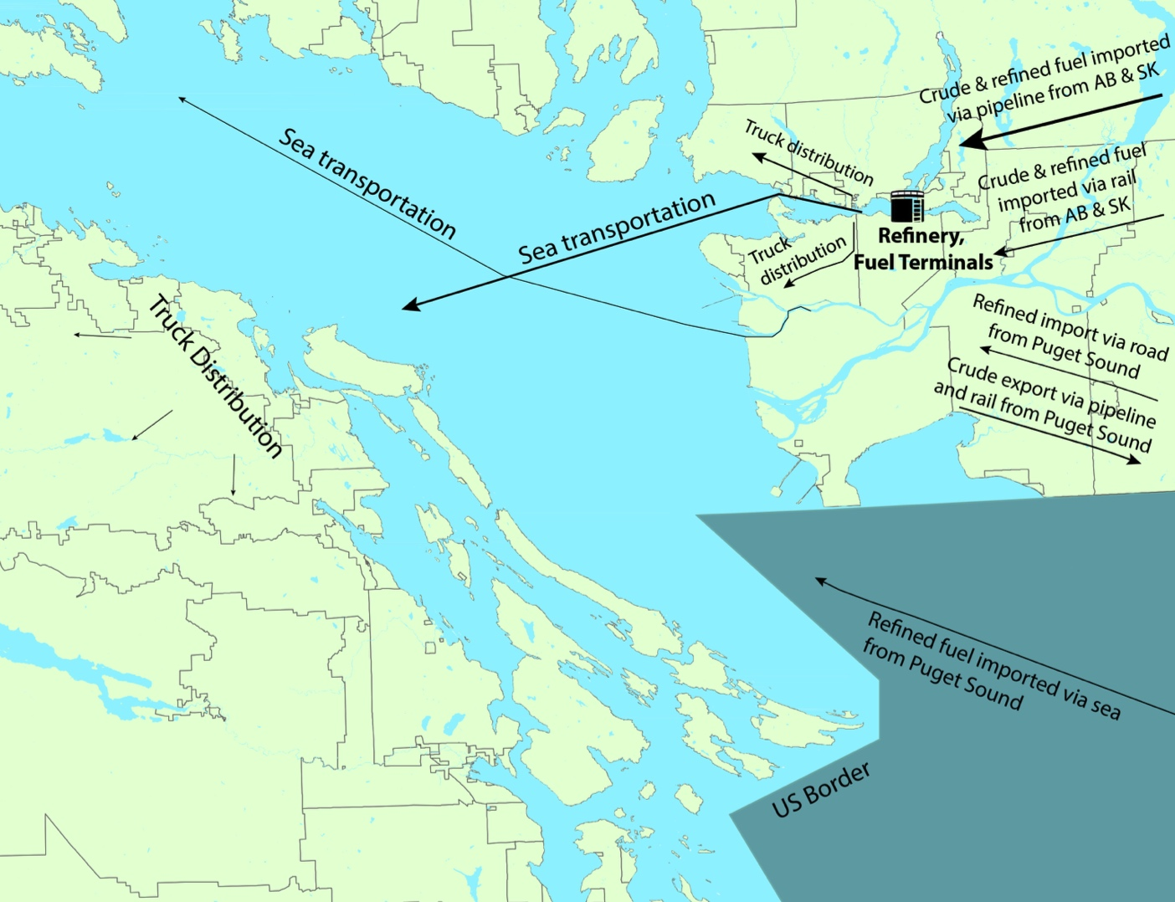

Figure 1. Fuel distribution on the Southern Coast of BC

Due to the number of stakeholders involved in the fuel distribution chain, a clear picture of the quantity of fuel being delivered and consumed in the region is difficult to obtain. However, estimates of the supply and demand of fuel are crucial in the development of regional emergency plans. While the goal of this report is not to obtain exact estimates of fuel flows in the Province, this section summarizes efforts to catalogue the main suppliers, distributors, and consumers of fuel in the region. The information presented in this section is based on publicly available data, indirect information, and reasonable assumptions. The gaps present in this data emphasize the challenges of this task.

### 3.1 Fuel consumption

An indirect estimate of fuel consumption per capita in Canada can be obtained from the 2016 population data collected by Statistics Canada (Statistics Canada, 2016a) and the 2016 Canadian Association of Petroleum Users report on refined fuel consumptions (Canadian Association of Petroleum Products, 2016). Combined, these reports show the average Canadian consumes 18 barrels (bbl) of fuel per year.

In BC, the most recent appraisal of liquid fuel consumption was found to be 181,000 bbl/day in 2009. With the average per capita consumption being recorded as 15 bbl/year (Minister of Industry, 2013). Concurrently, StatsCan data for 2015 reported gasoline sales at 80,200 bbl/d and diesel sales at 31,900 bbl/d (Statistics Canada, 2016b). Though these are approximations, per capita consumption data can be used in inferring fuel flows in the absence of direct data. A summary of the fuel demand for key coastal regions in British Columbia can be found in Table 1, below.

The overall consumption pattern has been categorized into three leading sectors by StatsCanada - Industrial, Transportation, and Other. Other includes, but is not limited to, pump sales, agricultural, residential, public administration, and other institutional means. Across Canada, approximately 85% of the fuel consumed is for transportation, while industrial activities accounts for 10%, and other accounts for 5% of total consumption (Statistics Canada, 2016 b).

|  |  |
| --- | --- |
| **Table 1. Estimated fuel demands in Coastal BC** | |
| **BC Coastal Region** | **Demand (bbl/d)** |
| Lower Mainland | 139,660a |
| YVR Airport | 45,000b |
| Vancouver Island | 40,537c |
| Powell River | 902 c |
| Mid Coast | 336 c |
| North Coast | 361 c |
| Notes: |  |
| a - based on average per capita demands | |
| b - based on forecasts made by YVR in 2007 (http://www.bcuc.com/Documents/Proceedings/2007/DOC\_16798\_C2-4\_VAFF\_Evidence.pdf) | |
| c - Brown (2016) |  |

### 3.2 Sources and conveyance of fuel

The approximate quantities of crude and refined oil movement within the Lower Mainland is depicted in figure 2. This fuel flow diagram has been developed using publicly available data, averaged over a one-year period. Seasonality is present in the consumption of fuel, with winter periods requiring less fuel than the summer. During winter mining and forest industries reduce operations, decreasing the local fuel demand, in addition the summer periods see an increase in population and travel due to tourism, increasing fuel demand.

The bulk of liquid fuels used in the province is imported from Alberta and Saskatchewan via pipeline and railcars. In addition, Washington State, USA, imports refined products to BC via marine barges and, at peak demand, tanker trucks. A small amount of conventional crude oil, approximately 11,000 bbl/d, is produced in BC and refined at the Huskey Energy, Prince George Refinery. BC also exports crude oil to Washington State, USA.

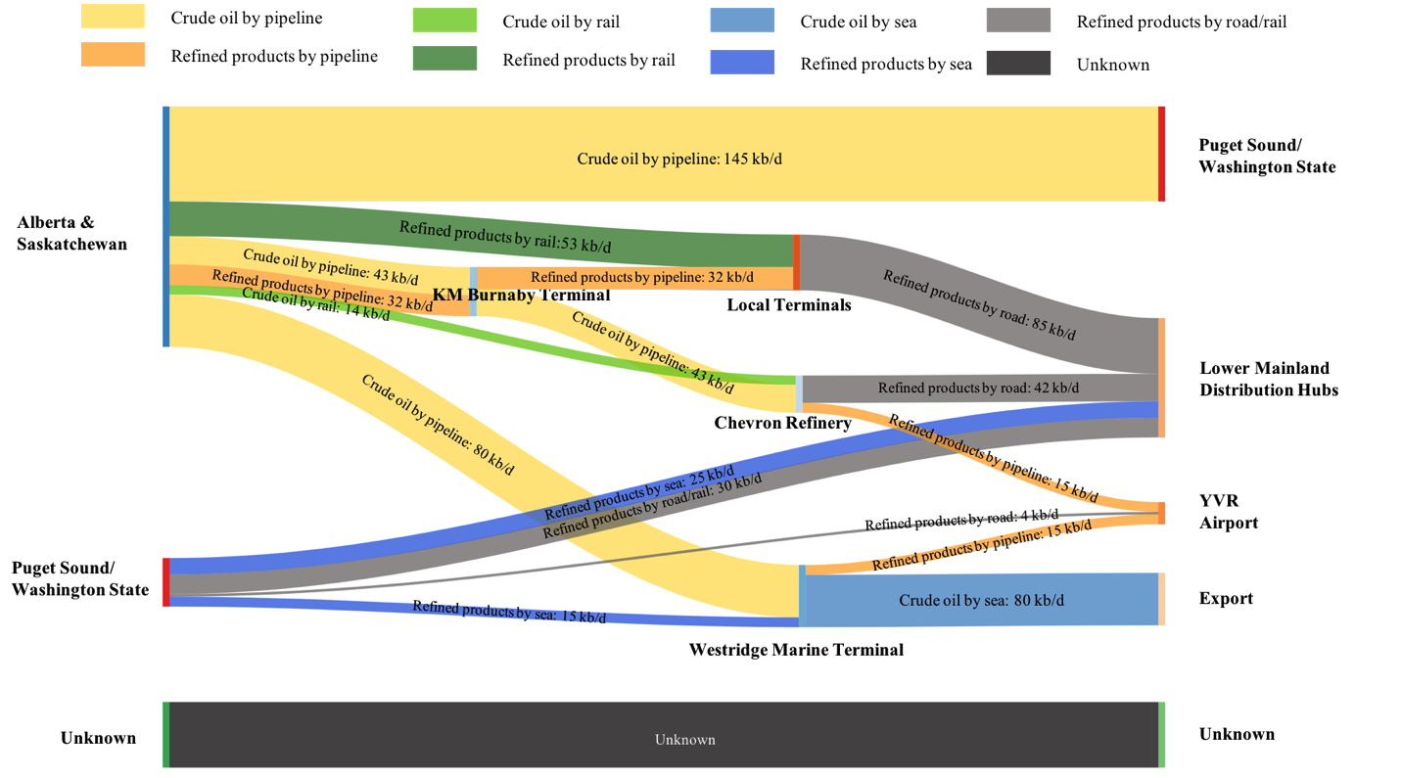

Figure 2. Sources and conveyances of fuel in the South Coast BC

Alberta and Saskatchewan supply the majority of fuel to BC’s south coast. The Kinder Morgan Trans-Mountain Pipeline (TMPL) is the only pipeline crossing the Rocky Mountains. The pipeline begins near Edmonton, Alberta and stretches 1150 km to its end points on the Burrard Inlet and in Puget Sound, Washington State, USA. TMPL is capable of carrying crude and refined fuel in batches with the reported capacity to be 300,000 bbl/d.

Once in BC, the fuel products from the pipeline are delivered to the Kinder Morgan Burnaby Terminal for temporary storage and distribution (capacity 1,680,000 bbl). Local pipelines are used to transport the fuel to local fuel terminals or the Chevron refinery. Fuel destined for export is transported to the Westridge Marine Terminal (capacity 395,000 bbl). In addition, significant quantities of crude oil and semi-refined products are exported to refineries in Puget Sound, Washington State (Kinder Morgan, 2015a). The location of these terminals is shown in figure 3.



Figure 3. Main fuel terminals in the south coast BC

The increasing demand for oil products and the closure of smaller, local, refineries has led the demand of fuel in BC to vastly exceed the local production capacity. This puts reliance on TMPL to operate at capacity and an increasing dependence on expternal forms of fuel transportation to meet local demand. For example, in 2009, 52,000 bbl/d of oil products were transported to BC by rail. By 2013, this volume increased to 80,000 bbl/d (Pynn, 2015). Today, rail provides approximately 35% of all BC’s petroleum products, coming from Alberta, Saskatchewan, and Washington State. Rail transportation of fuel is expected to continue to grow in relation to demand in the coming years (Canadian Association of Petroleum Producers, n.d.)

While pipeline and rail supplies most fuel imported to the Lower Mainland, some of the refined products - notably Jet A - are exported from Puget Sound via tanker or barge and arrive in BC at the Westridge Marine Terminal in the Burrard Inlet. Truck transportation from Puget Sound is also used to deliver fuel to the Lower Mainland, particularly the YVR airport.

Once the petroleum products arrive in BC, the fuel is destined to either the local refinery, one of three fuel terminals, or the YVR airport for local consumption. Semi-refined and crude products arriving in the province via TMPL are delivered to the only local refinery still in operation, the Chevron Stanovan, in Burnaby. Chevron Stanovan has a refining capacity of 57,000 bbl/d and is responsible for nearly 30% of the province’s gasoline (Moreau, 2012) and supplies about 40% of the fuel consumed by YVR airport using the Trans-Mountain Jet Fuel pipeline (Vancouver Airport Fuel Facilities Corporation, n.d.). The Chevron Stanovan terminal is also directly connected to the CN railway (Pynn, 2015) and receives approximately 8,000 bbl/d from rail (Pynn, 2013).

The three fuel terminals in the Lower Mainland are owned and operated by independent providers. Refined products delivered via TMPL are destined to Suncor Oil, on the Burnaby-Port Coquitlam border, and for domestic fuel needs (Moreau, 2012). Imperial Oil (IOCO) Esso, in Port Moody, is supplied mostly by rail from Edmonton with a focus on Marine Gas Oil (used by tugs and ferries), diesel flux, intermediate, and bunker fuel (City of Port Moody, n.d.). Finally, Shell owns and operates the Shellburn Terminal located in Burnaby and focuses on local demand. The Shellburn Terminal receives fuel from barges or ships coming from the U.S. and rail from Alberta and does not use TMPL (Moreau, 2012).

The YVR Airport receives fuel from trucks and barges coming from the U.S. An average of 25 truck deliveries are received at YVR daily, with up to 35 deliveries being made during peak periods, such as summer and holiday periods (Vancouver Airport Fuel Facilities Corporation, n.d.). In addition, barges deliver fuel to the Westridge Marine Terminal where it is combined with fuel from the Chevron Stanovan fuel terminal and sent via the Trans-Mountain Jet Fuel pipeline to YVR.

By using publicly available data, figure 2, above, provides an overview of BC’s dependence on refined product deliveries from Alberta and displays the different levels of dependency by product type. Table A.1 in Appendix I, which is calculated from Statistics Canada data for 2016, provides an overview of major products used in BC and the ratio of domestic sales to local production and imports from Alberta and Puget Sound. The imbalances in the data and the disparities between figure 2 and the table in appendix I, indicates that a significant part of regional fuel flow remains unknown. This is labeled as ‘unknown’ and shaded in black in Figure 2. There is no publicly available data about volume, origins, destination, and transportation modes, a critical gap.

# 4. Fuel distribution within the region

Once the fuel is delivered to BC it is distributed across the Southern Coast using both land and marine transportation (see Figure 1, above). Fuel destined for the Lower Mainland is transported directly from the distribution centers by land delivery. Fuel for coastal communities is first transported from distribution centers to nearby marine docks by pipe or truck, and then shipped to the destined ports for local distribution.

### 4.1 Land

Transportation from distribution centers to end users is accomplished through similar modes as wellhead transportation. Typically, refined fuel is either collected from racks at the refinery by truck or pumped directly through pipelines to tanks or port facilities.

Multiple companies truck fuel from storage facilities to the docks for marine transport to coastal distribution points and ultimately, end-users. Parkland Industries Ltd manages a large proportion of fuel distribution originating at the storage and refining facilities. The contract for fuel is between Parkland and the refinery, which determines the volume and location of fuels available.[[2]](#footnote-2) Independent distributors of commercial fuels hold contracts with Parkland, who allocate the fuel resources between their customers. At any time, Parkland can hold fuel contracts with multiple distribution terminals, allowing flexibility in supply in the event of a minor fuel disruption or delay at one of these centers. Redistribution of fuel has occurred previously. For example, in recent years, the Imperial Oil Terminal had a failure at its racks. As a result, Parkland redirected some of its clients to the Shell Terminal to obtain their fuel requirements. Due to the nature of the network, interchanging between the two companies has no effect on overall relationships, and the end user has a reliable supply of fuel.

Pipelines are also prevalent in the transfer of oil from storage facilities to barges, marine tankers, and from dockside ships to nearby tank farms. For example, the Vancouver International Airport is served via Kinder Morgan Trans-Mountain Jet Fuel (TMJ), a dedicated 41 km pipeline between Chevron Burnaby, Westridge Marine Terminal, and Vancouver International Airport (Kinder Morgan, 2015b). Chevron provides close to 50% of the aviation fuel transported via TMJ to the airport. A similar volume is delivered by tanker or barge to Westridge Marine Terminal. However, during peak times, additional supply is provided to the airport by up to 35 tanker trucks per day (over 8000 bbl/d) from Cherry Point refinery in Washington State.[[3]](#footnote-3) Aside from these services, there are additional trucking services between Cherry Point, Washington State, and prominent locations in BC.

Once the fuel arrives to coastal communities by marine transportation, trucks are the last link in fuel delivery. In the case of tanker vessels, trucks deliver fuel from local storage tanks to fuel retailers, and end-users. Moreover, in the case of roll-on roll-off ships, tanker trucks are key at both ends of the supply chain; trailers can also be used directly from barges. Trucks transport fuel to petrol stations and local businesses, dispensing fuels to the capacity of the recipient’s onsite tanks. In the Lower Mainland, twelve registered companies advertise transportation of fuel. Of these, several distribute fuel exclusively from refineries and storage facilities to the Lower Mainland. Some, however, service both the mainland and island or coastal communities. The majority of these are independently owned, although some companies are a subsidiary of a larger fuel company and exclusively transport their products.

### 4.2 Marine transportation

Fuel barges and marine tankers are both utilized to serve BC coastal communities. The larger corporations use marine tankers which are loaded and unloaded at a dock by pipeline. Service to medium and smaller communities, that have a local road network, uses roll-on-roll-off inventory, and their barges carry fuel in trailers. This portfolio of marine vessels provides flexible transportation options to meet the needs of end-users. They require far less fixed infrastructure but require cleared shipping lanes, safe harbours, docks and mechanisms to deliver cargo to shore.

The density of marine fuel delivery is displayed in figure 4. The density map contains the movement of 81 vessels during 2015, making 381 tracks. Due to the nature of the data, most vessels included are tugboats, all of which have AIS receivers installed. This data provides an estimate of fuel deliveries, though some discrepancies may exist if deliveries are made by boats without the AIS receiver activated.[[4]](#footnote-4)



Figure 4. Density of fuel vessel tracks (AIS shipping data)

Figure 4 highlights the major distribution centers on Vancouver Island, namely, ESSO Nanaimo, Suncor Nanaimo, Shell Chemainus and Chevron Cobble Hill. These distribution centers are frequently visited by various marine vessels to support the nearby communities. While fuel deliveries are made in more rural locations, the frequency of such visits are substantially lower.

Based on the AIS tracking data, the number of distinct vessels and the number of visits each vessel makes can be estimated for each distribution center (Table 2, below). By gathering the vessel characteristics, the volume of fuel being transported during a delivery can also be estimated. This information can then be combined to calculate the amount of fuel destined for each distribution center. However, as mentioned before, the AIS data only tracks part of the fuel deliveries in the region. In this vein, the specific volume being calculated does not represent actual quantities; instead, the share of fuel deliveries to each distribution center is calculated, as shown in Table 2. Figure 4, above, presents the location of these the distribution centers in Vancouver Island and their associated fuel terminals in the Lower Mainland.

|  |  |  |  |
| --- | --- | --- | --- |
| **Table 2. Frequency of deliveries to Fuel Distribution Centers on Vancouver Island\*** | | | |
| **Island distribution center** | **Number of distinct vessels** | **Deliveries per year** | **Percentage of Fuel Received** |
| ESSO Nanaimo | 7 | 121 | 36.0% |
| Suncor Nanaimo | 7 | 82 | 40.1% |
| Shell Chemainus | 8 | 23 | 5.5% |
| Chevron Cobble Hill | 10 | 95 | 18.5% |
| \*Courtesy of C. Hilliard, MEOPAR. Estimates are for fuel delivery, inferred from AIS vessel tracking data. | | | |

Several shipping companies transport fuel within the Southern Coast of BC, each with their own routes and service areas. It is critical to note that the marine network of fuel transportation is separate from passenger services and the general freight network. Each company involved in the fuel transportation system uses different routes, ships, and frequencies. This is summarized below and depicted in figure 5.

* Island Tug and Barge (ITB), with an annual capacity to deliver 27,500 bbl/d, is the largest carrier of refined fuel to Vancouver Island. ITB collects fuel at the terminals on the Burrard Inlet and delivers it to the respective distribution centers on Vancouver Island. The ITB vessels visits not only Nanaimo, Chemainus, Cobble Hill, but also Courtenay-Comox and Campbell River.
* City Transfer offers truck and barge shipping services. Their ships depart from Richmond, where products destined to Powell River, including fuel, are collected and dispatched.
* North Arm Transportation, based on Mitchell Island, Vancouver, ships fuel to small communities (including First Nations communities) in the Mid and North Coast of BC. Their operations cover coastal BC, from Vancouver to Prince Rupert, but they do not operate on Vancouver Island. North Arm Transportation supplies two barges a month. One delivery goes from Vancouver to Bella Bella in a 10- 12-day trip. The second barge departs from the Mid Coast and delivers fuel to communities in the Haida Gwaii archipelago in an 18- day trip.
* Seaspan dominates bulk and hazardous cargo shipments. They operate between terminals located at Tilbury (in Surrey), Duke Point and Swartz Bay. Seaspan uses roll-on-roll-off and drop trailers for a small share of fuel delivery.
* BC Ferries’ ships can move fuel, but only on separate sailings from passenger runs. These additional regulations are cost-prohibitive, and trucking companies prefer to use other marine transportation options.

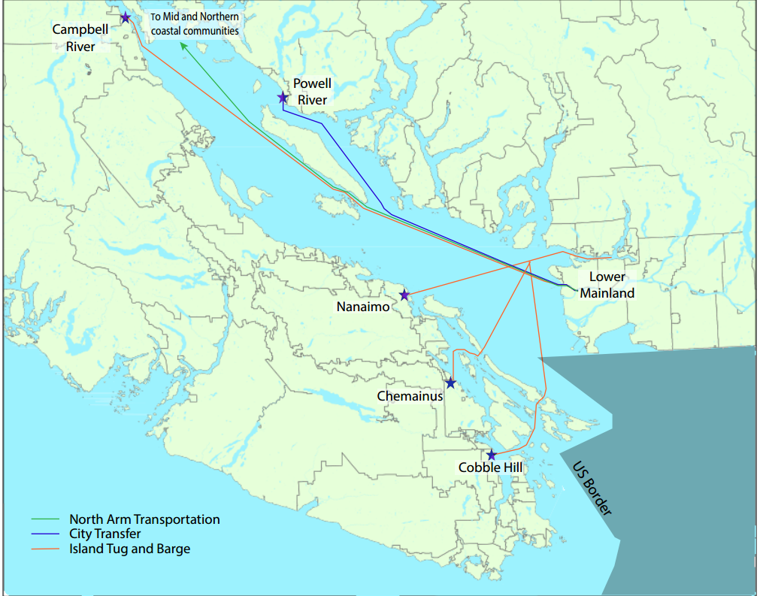

Figure 5. Routes of maritime fuel transportation for prominent companies

# 5. Communities dependent upon marine transportation

Coastal and island communities in southern BC rely heavily on the maritime transportation system to support their basic needs. These communities vary in size, connectivity, and frequency of delivery (from daily to monthly), as shown in Table 3. On-site storage facilities provide fuel supply security and are managed in accord with the frequency of delivery. Each tank owner-operator has their own fuel inventory management strategy – some keep their tanks as close to full as the supply-demand dynamic permits, others keep a smaller inventory to minimize costs. Improved fuel inventory strategies and post-disruption supply management can lead to significant enhancement in community resilience.

|  |  |  |
| --- | --- | --- |
| **Table 3. Fuel demand and supply frequency of refined products, by BC Coastal region\*** | | |
| **BC Coastal Region** | **Demand (b/d)** | **Frequency of Delivery** |
| Vancouver Island | 40,537 | Daily |
| Powell River | 902 | Two or three times per week |
| Mid Coast | 336 | Monthly |
| North Coast | 361 | Monthly |
| \*Canadian Association of Petroleum Products (2015); HATCH (2009). | | |

Different modes of vulnerability exist depending upon such factors as population size, location, connectivity, frequency of delivery, local storage capacity, and the inventory management strategy used. These factors influence the susceptibility to a fuel supply disruption and the effect a disruption would have on the community. Here we describe the fuel delivery system in place, and the related vulnerabilities associated with four representative communities.

Large population centers on Vancouver Island, such as Nanaimo, have several tank farms which are replenished daily. These communities are vulnerable to interruptions in the supply chain as they are prone to experiencing fuel shortages shortly after a disruption. However, these communities possess more resources and have a fuel demand high enough to allow them to independently negotiate fuel deliveries from alternative suppliers (IBI Group 2010).

Powell River and smaller Gulf Island communities are supplied by secondary services from Vancouver Island. Most fuel deliveries originate in the Lower Mainland and are transported through Nanaimo and other leading ports before local distribution. Many of these medium-sized semi-remote communities are only accessible by air or boat, making them dependent on maritime fuel deliveries. Powell River requests new fuel shipments when there is available space in the tank farms. With no regularly scheduled fuel supply from the Island, the community places a fuel delivery order when needed, approximately two to three times per week. This request is almost exclusively filled by City Transfer, a company that provides general freight transportation between the Greater Vancouver area and Powell River. Upon arrival, the fuel is stored in a number of independently owned tank farms awaiting local distribution.

In remote communities on the Mid Coast and North Coast, diesel power generation is supported through monthly fuel shipments. For this reason, these communities tend to keep large fuel reserves. However, this is changing as BC Hydro is taking over their operations. In Hartley Bay, for example, when the community operated their generation facility, they kept fuel reserves of two months, while now significantly lower reserves are kept on-hand.

These smaller communities capacity to handle fuel disruptions is greatly dependent on when in the fuel delivery cycle a disruption occurs. Interruptions in supply that happen right after a monthly delivery will be less severe if supply is restored in a few weeks. However, if a disruption in the fuel supply chain happens near the end of the cycle (i.e., right before a new delivery, when reserves are low) the community will have a limited capacity to respond.

The community, however, can adopt strategies within their authorities to respond to fuel shortages. In an emergency context, the community can restrain the fuel consumption to the volume that is sufficient to satisfy only emergency and essential services. Organizations and facilities that provide emergency services, such as medical, fire and police, would have priority to use the existing fuel reserve. The strategy could significantly reduce the local fuel consumption while ensuring the normal operation and order of the community, however these plans do not seem to exist. Powell River, for example, could reduce its fuel consumption to 25~30% of the regular consumption. The fuel is sufficient to support vehicles (ambulances, fire trucks, bulldozers, etc.) and diesel generators in critical buildings (hospitals, fire stations, police stations, etc.). This shows how communities have the able to increase their resilience with the use of improved emergency planning.

# 6. Organizations involved in the fuel transportation system

Fuel transportation within BC is a shared responsibility involving many organizations. During day-to-day operations, the supply chain is run by the private sector with oversight from provincial and federal regulators. As described in detail above, the fuel supply enters BC from five major oil and gas corporations: Imperial Esso, Suncor Energy, Shell Canada, Chevron Canada, and Kinder Morgan, using pipeline, rail, truck, and marine tankers. Once in the Province, a multitude of local distributors delivers refined fuel to local communities; this is done by the shipping and trucking industry. When marine transportation is involved, local ports become key hubs in the supply chain as all fuel destined to maritime communities must flow through a small number of ports. This is particularly the case for shipping fuel to Vancouver Island and semi-remote and remote communities in northern British Columbia which are dependent on sea transportation for all liquid fuel deliveries. Refer to Appendix III for an initial list of key stakeholders in the fuel supply chain.

During normal operations, the government has no direct involvement with the fuel supply chain. However, oversight is provided by key government agencies to ensure the safe transportation of fuel. These include Transport Canada, Public Safety Canada, the Canadian Coast Guard, and the BC Ministry of Transportation and Infrastructure.

In the event of an emergency, the level of government oversight drastically increases with a range of government departments and organizations playing a role in response and recovery efforts. These include: Transport Canada, the Canadian Coast Guard, the Department of Fisheries and Oceans, Environment and Climate Change Canada, the Department of National Defense, Public Safety Canada, Emergency Management British Columbia, BC Ministry of Transportation and Infrastructure, local emergency management offices, local port authorities, and marine emergency response organizations. The private sector, including the shipping and trucking industries, also play a role in protecting proprietary assets, serving customers, and maintaining business function, see appendix III.

If a State of Emergency is declared in the Province, the provincial government has rights under the Emergency Program Act to procure all assets in the Province needed for emergency response, including fuel. For this shift of power to be successful, extensive pre-planning is required, including negotiations, signed contracts, and general engagement with all stakeholders. At this point, this pre-planning does not appear to have been completed, nor does it appear to be a priority for immediate action. For instance, there are no contracts in place for the use of private sector services and assets by government agencies or pre-established negotiations between fuel suppliers, local delivery companies, and emergency management agencies. This includes limited forethought into how fuel will be prioritized and rationed to ensure that emergency response activities and priority organizations receive the fuel supply they require to operate.

Of additional concern, different segments of the fuel supply chain do not appear to be in regular contact with one another. The land and marine systems are operated independently, and both are removed from emergency response planning. As summarized by two stakeholders, current plans are “very fragmented and siloed in terms of coordinated awareness and performance sharing” and “they don’t know our plans and we don’t know their plans”. Some interviewees recalled that in the lead up to the 2010 Olympics, efforts for emergency response was a priority; however, this attention has not continued.

These findings are supported by the survey responses, most of which were government employees.[[5]](#footnote-5) Responses indicate stakeholders are aware of, and much of the time have worked with, the key players in responding to emergencies within the maritime fuel system, with the exception of shipping and trucking companies and associations. This indicates that knowledge of, and interconnections between, the key organizations within the government sector is high, but less is known about shipping and trucking companies where the private sector plays a critical role. This limited integration is made more difficult as staff turnover is high within government agencies and limited institutional memory.

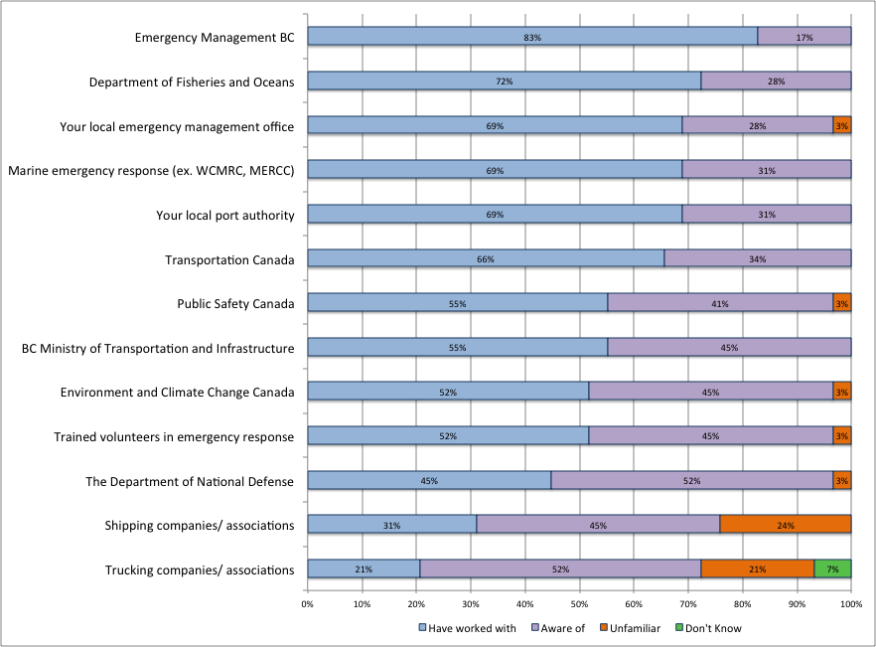

Figure 6. Level of familiarity with key maritime fuel system stakeholders. N=29

Efforts have been made to engage the private sector in emergency response planning, both in the research reported here and in government emergency planning, though this has been largely unsuccessful. Most companies have their own emergency response and business continuity plans, but there is a clear need for public-private partnerships. This is critical to establish as the public sector will be relying on private services (such has transportation equipment and expertise) for emergency response, particularly as it is the private sector that are the experts in the day-to-day operations of the fuel supply system. As the provincial government has the right to take over assets if a State of Emergency is declared, having pre-established partnerships and signed contracts are critical as emergency managers will not have the capacity or expertise in fuel distribution.

Unconventional emergency response actions should also be considered in the process of negotiating contracts and establishing relationships. For instance, what sort of assets do local people own and are they willing to donate this to emergency response? In the event of an employee shortage, can critical services be run with fewer people than regulatory requirements? Can former employees be certified to run critical services? Can recently decommissioned vessels be quickly re-commissioned? These are just a few examples of how leniency in regulatory requirements may allow for an improved emergency response. Government officials have had limited interest in discussing leniency of regulations despite past examples of this being done. Having these discussions and setting guidelines prior to an event would allow for forethought and application of an analytic process rather than acting on impulse in an emergency situation.

Overwhelmingly, stakeholders feel that the provincial government is responsible for taking action to reduce the risk of a disruption in the fuel supply chain and to plan for emergency response actions. Stakeholders are looking to the provincial government for leadership and are relying on provincially created emergency response plans. This was particularly the case for the process of prioritizing fuel allocation in BC (89% of respondents) and fuel availability among users (62% of respondents). However, the provincial government currently has no plans for allocating fuel resources or continuity plans for the fuel system. At the most basic level, there is not even an understanding of who the key players are, what resources are available, and which communities and sectors may be in the greatest need of emergency fuel support. This should be a critical concern and focus area for the Province as 63% of respondents indicated that the provincial government is ultimately responsible for managing fuel distribution in an emergency.

One reason provided for the lack of planning for the provision of fuel is the limited resources dedicated to emergency management. Minor events, such as single dwelling landslides, take up a considerable amount of time, resources, and focus of provincial emergency managers, limiting the opportunity for large-scale and long-term emergency planning.

In terms of how potential disruptions are currently being prepared for, 29% of survey respondents indicated that they were doing nothing to reduce the likelihood of disruption to the fuel supply chain while 33% of respondents indicated that they were undertaking some action. Results for building capacity to respond to a disruption were more neutral, with 67% of respondents indicating that a little or some action was being done with only 17% indicating that a lot of action was being done. This indicates that there is substantial room to reduce the likelihood of a disruption and to build capacity within the system.

Interviewees raised further concerns. First, federal government requirements for sole source providers have proven to delay emergency response, particularly for oil spill protocols. The processes requires that the spiller pays, leading to prolonged period of determining who is legally responsible, and sourcing appropriate contracts. Second, there is significant dependency on refined fuel being brought into the province and limited redundancy to deliver this fuel to marine dependent communities. This lack of redundancy and interoperability has also been raised in regards to the number of qualified employees, equipment, and service providers available. Rural and semi-rural locations have also raised concerns over the emphasis placed on central locations and a dependency on these locations to supply the needs of downstream communities. These oversights and associated risks are furthered compounded by the shift towards just-in-time delivery, lowering the resilience of the system as a whole. These oversights, in part, could be addressed if a system-wide perspective was taken.

The significance of these results can be summarized by an interviewees’ perception of the fuel system - “without fuel everything stops”. Nevertheless, most in the system seem to have a limited awareness of the system as a whole and how heavily society depends on fuel to function.

# 7. Recommendations and Conclusion

This report has made initial efforts to characterize the fuel supply system, identify who the critical stakeholders are, and address organizational opportunities to strengthen the systems resilience. Results indicate the critical need for coordinated action to be taken in coastal BC to prevent disruptive fuel shortages and the need for improved information to overcome gaps in the data. Without these efforts being taken, the fuel supply chain remains a critical vulnerability for coastal BC communities’ ability to function in the event of a disruption, and ultimately puts BC at a greater risk for devastating impacts from a hazardous event.

Based on the findings in this report, the following recommendations are made:

1. Improved emergency plans:  
   1. The provincial government should lead detailed pre-planning efforts for potential fuel disruptions that enable rapid and coordinated emergency response across local, provincial, and federal governments. In particular, a fuel prioritization plan should be created and formal agreements be put in place. Unconventional emergency response actions should be discussed and a common understanding held on acceptable actions. These results should be communicated to all stakeholders.
   2. Accordingly, planning efforts need to directly engage all stakeholders -- especially private sector organizations involved in day-to-day fuel delivery -- to ensure greater preparedness and fuel allocation priorities for emergency services and to meet expectations of the general public in the event of a fuel disruption. Due to the demands placed on emergency managers in an emergency situation and the specialized knowledge held by the private sector, it is unlikely that emergency responders will take full control over the fuel supply. As such, clarity is needed on realistic actions and clear responsibilities of the public and private sector.
   3. Planning efforts should include all BC coastal communities, particularly those in down-stream locations. Due to differing needs in coastal and rural communities compared to urban centers, a wide scope of communities should be included in planning efforts. Particularly fuel supply reserves, differences in perceptions of risk, and connectivity of communities should be addressed.
   4. Formal agreements should be put in place with conveyers of critical information identified and alternative suppliers outlined. Appendix III contains an initial list of stakeholders within the fuel supply chain. Relationships between these stakeholders should be strengthened throughout the planning process.
   5. All planning efforts ought to be discussed and implemented with urgency so an analytic process can be undertaken. Pre-planning would allow for improved emergency response and decreased vulnerability in the event of an emergency. Planning efforts should be reviewed regularly to allow for adaptive actions to be taken.
   6. Planning efforts should include both short- and long- term risks and resilience actions. This may require that certain groups focus only on catastrophic planning, while others focus on the smaller hazards that occur more frequently.
   7. Clear communication between stakeholders and local communities should occur at all stages of planning.
   8. Planning efforts should be based on robust information about the fuel supply chain in normal and emergency situations.
2. Overcoming information gaps
   1. Numerous information gaps exist in the fuel supply system that should be examined further to understand the full nature of fuel disruption risks. Inconsistencies and incomplete data should be addressed and studied directly. Particular areas where gaps in data exist include:
      1. Information about the fuel reserve volume in local communities
      2. Storage facility vulnerabilities
      3. Fuel-pumping capacities during power outages
   2. Further information is needed on anticipated fuel demand changes during an emergency event and supply chain disruption. This includes calculating fuel needs of emergency responders and having a better understanding of how the general public is anticipated to respond to a fuel shortage.
   3. Assessments should be made on the different types of potential disruptions, and the effects these disruptions would have, on the supply chain. The fuel supply system faces a myriad of risks; these should be identified explicitly and examined in relation to anticipated effects on the fuel supply chain for each community.
3. System-wide perspective
   1. Planning for fuel supply disruptions must take a system-wide perspective on vulnerability and resilience-building opportunities, considering not only physical networks and their functional operations but also the organizations, rules, and relationships involved in how the system would respond to a disaster.

# 8. Acknowledgements

The authors would like to thank all those who participated in the various stages of data collection required to complete this report. Particular acknowledgement goes to Dr. Terje Haukaas, Casey Hilliard and Bethany Dobson. Satellite AIS data used was provided by exactEarth ([www.exactearth.com](http://www.exactearth.com)), as part of the exactEarth – MEOPAR – Dalhousie University academic agreement. This research was funded by the Marine Environmental Observation, Prediction, and Response (MEOPAR) Network of Centres of Excellence.

# 9. References

AIR Worldwide (2013): Study of impact and the insurance and economic cost of a major earthquake in British Columbia and Ontario/Québec. Report commissioned by the Insurance Bureau of Canada. Boston, Mass.: AIR Worldwide.

Auditor General of British Columbia (2014): Catastrophic earthquake preparedness. March. 44pp. Retrieved March 6, 2016, from [www.bcauditor.com](http://www.bcauditor.com)

Bull, Housser & Tupper LLP (2007). *Trans Mountain (Jet Fuel) Inc. (“TMJ”) Application for Approval of Tolls and Accelerated Depreciation under section 7 of the Pipeline Act Project: 3698466 / Order P-2-07*. Retrieved April 1, 2017, from <http://www.bcuc.com/Documents/Proceedings/2007/DOC_16798_C2-4_VAFF_Evidence.pdf>

Canadian Association of Petroleum Products (n.d.). “Rail” Canadian Association of Petroleum Producers. Retrieved June 5, 2017, from <http://www.capp.ca/canadian%20oil%20and%20natural%20gas/infrastructure%20and%20transportation/rail>

Canadian Association of Petroleum Products (2016). “Crude Oil Statistics.” Canadian Association of Petroleum Producers. Retrieved April 1, 2017, from <http://www.capp.ca/publications-and-statistics/statistics/basic-statistics>

Chevron Canada (n.d.). *Burnaby Refinery*. Retrieved April 1, 2017, from http://www.chevron.ca/our-businesses/burnaby-refinery

City of Port Moody (n.d.). *Port Moody industry profiles: Imperial Oil*. Retrieved April 1, 2017, from <http://www.portmoody.ca/index.aspx?page=842>

Holguín-Veras J., Taniguchi E., Jaller M., Aros-Vera F., Ferreira F., Thompson R.G., (2014): The Tohoku disasters: Chief lessons concerning the post-disaster humanitarian logistics response and policy implications, Transportation Research Part A 69, 86-104.

Energy Policy Office (2006) Washington State Energy Assurance and Emergency Preparedness Plan, Department of Commerce, State of Washington.

Kinder Morgan. (2015a). *Kinder Morgan in Canada.* Unpublished manuscript.

Kinder Morgan. (2015b). *Trans mountain jet fuel system.* Retrieved April 1st, 2017, from [http://www.kindermorgan.com/business/canada/transmountain\_jetfuel.aspx](http://www.kindermorgan.com/business/canada/transmountain_jetfuel.aspx" \t "_blank)

MacNeil, A. and D.J. Keefe (2015) The Nova Scotia fuel shortage: Report of the independent review panel. Retrieved March 2, 2016, from <http://novascotia.ca/dma/fuel-supply.asp>

Maritime Commerce Resumption Committee (MCRC), Pacific Region (Vancouver, 2010). Regional Maritime Commerce Resumption Plan. 31pp.

Minister of Industry. (2013). *Report on energy supply and demand in canada*. Ottawa: Statistics Canada.

Moreau, J. (2012). *Who's moving oil on the Burrard Inlet?* Retrieved April 1, 2017, from <http://www.burnabynow.com/news/who-s-moving-oil-on-the-burrard-inlet-1.413969>

Oil Sands Magazine (n.d.). *Why Vancouver desperately needs a new oil refinery*. Retrieved April 1, 2017, from <http://www.oilsandsmagazine.com/news/2016/3/03/why-vancouver-desperately-needs-a-new-oil-refinery>

Pynn, L. (2013). *The high stakes of transporting oil by rail.* Retrieved April 1, 2017, from http://www.vancouversun.com/technology/high+stakes+transporting+rail/9124923/story.html

Pynn, L. (2015). *Rail shipments of crude oil continue to increase in BC* Retrieved April 1, 2017, from [http://www.vancouversun.com/news/Rail+shipments+crude+continue+increase/10733394/story.html](http://www.vancouversun.com/news/Rail+shipments+crude+continue+increase/10733394/story.html" \t "_blank)

Regional Catastrophic Preparedness Grant Program (RCPGP, 2014), Supply Chain Project Report, Retrieved June 3, 2017, from <http://www.regionalresilience.org/uploads/2/3/2/9/23295822/supply_chain_project_-final_report.pdf>

Smythe, T.C. (2013). Assessing the impacts of Hurricane Sandy on the Port of New York and New Jersey’s maritime responders and response infrastructure” *University of Colorado Natural Hazards Center, Quick Response Report No. 238.*

Statistics Canada (2016a). *Population by year, by province and territory, table 051-0001*. Retrieved April 1, 2017, <http://www.statcan.gc.ca/tables-tableaux/sum-som/l01/cst01/demo02a-eng.htm>

Statistics Canada (2016b). *Sales of fuel used for road motor vehicles, table 405-0002*. Retrieved April 1, 2017, http://www.statcan.gc.ca/tables-tableaux/sum-som/l01/cst01/trade37c-eng.htm

Transport Canada, US Coast Guard, and Pacific Northwest Economic Region (2012) US-Canada Maritime Commerce Resilience Initiative. 188pp.

Vancouver Airport Fuel Facilities Corporation (n.d.). *Vancouver airport fuel delivery project*. Retrieved April 1, 2017, from http://www.vancouverairportfuel.ca/adminpanel/files/pdfs/VAFFC\_Brochure.pdf

# Appendix I. Fuel production, imports and exports in BC

|  |  |  |  |  |  |  |  |
| --- | --- | --- | --- | --- | --- | --- | --- |
| **Table A.1. BC production, imports and exports as % of domestic demand (2016)** | | | | | | | |
| *(% of Domestic Sales)* | All refined Products | Motor Gasoline | Diesel | Jet Fuel | Heavy Fuel Oil | Lubricating Oils & Greases | Aviation Gasoline |
| Refinery Production | *25* | *27* | *49* | *24* | *80* |  | *0* |
| From Alberta | *34* | *23* | *111* | *2* | *1* | *13* | *90* |
| To Yukon | *11* | *6* | *35* | *1* | *10* | *0* | *13* |
| From Wash State | *9* | *1* | *7* | *43* | *91* | *28* | *0* |
| Exports | *5* |  | *10* |  | *117* |  |  |
| Domestic Sales (b/d) | 197,650 | 94,104 | 27,591 | 18,810 | 1,899 | 1,838 | 73 |
| Source: Calculated from data retrieved from Statistics Canada CANSIM table 134-0004. | | | | | | | |

Column 1 displays data for all refined product production and flows into and out of BC. It shows a 14% imbalance between production and consumption. According to US Energy Information Agency, imports from Washington State are closer to 13% of BC demand reducing the imbalance by 4%, but inconsistencies in data about fuel supply is endemic.

From the perspective of resilience to fuel supply disruptions, a more telling picture can be gleaned from the balance of flows in specific refined products. For example, TMPL provides all the aviation gasoline used in BC and Yukon. As small fixed wing aircraft are key to swift delivery of personnel and medical supplies to remote communities, this table highlights the need for careful cache management for availability during an emergency.

Clearly, 2016 data on jet fuel is missing 30% of supply. Furthermore, 43% of reported demand for jet fuel and 53% of heavy fuel oil was imported from Washington State. Supply from Washington State is vulnerable to any events disrupting delivery of crude to Puget Sound refineries or the shipping channels and terminals serving the route between them and terminals on Burrard Inlet. However, in the wake of a local emergency, far lower traffic is expected at Vancouver International Airport and Port Metro Vancouver.

# Appendix II. Study Participants

Note: some participants are not named, according to their request.

#### Federal Government

Edward Dahlgren, Nanaimo Port Authority

Captain Bernie Dumas, Nanaimo Port Authority

Rodney Grounds, Nanaimo Port Authority

#### Provincial Government

Maurie Hurst, Emergency Management British Columbia (EMBC)

Heather Lyle, Emergency Management British Columbia

Steve Newton, Emergency Management British Columbia

Patricia Wong, Ministry of Transportation and Infrastructure

Anonymous Contributor 7, Emergency Management

#### Local and Regional Government

Mike Andrews, North Shore Emergency Management

Tor Birtig, City of Powell River

Shawn Cator, City of Powell River

Chad Pacholik, Integrated Partnership for Regional Emergency Management (IPREM)

Al Radke, Powell River Regional District

Edward Robinson, Hartley Bay Council

Laura Roddan, Powell River Regional District

Ryan Thomas, Powell River Regional District

Mike Wall, Powell River Regional District

#### Private Sector

Pat Docking, PDocking Consulting Ltd.

Alan Galambos, Binnie Engineering Consultants

Kevin Gardner, West Coast Marine Response Corporation

Thomas Gregoire, Chamber of Shipping, British Columbia

Lee Hammond, West Coast Marine Response Corporation

Ferdi Van De Kuijlen, Island Tug & Barge Marine Group

Captain Stephen Brown, Chamber of Shipping, British Columbia

Gino Stradiotti, North Arm Transportation

Matt Stradiotti, North Arm Transportation

Louise Yako, British Columbia Trucking Association

Anonymous Contributor 11, Transportation

Anonymous Contributor 15, Transportation

# Appendix III. Stakeholder List

The following is a list of key stakeholders in the fuel supply system that have been identified as critical by our research participants. This list is not indicative of all players associated with the fuel supply system but represents some key contacts.

An asterisk indicates those who are not directly involved with the fuel supply system in normal operations but play a critical role when an event occurs.

Federal

Transport Canada

Department of Fisheries and Oceans \*

Environment and Climate Change Canada\*

The Department of National Defense\*

Canadian Coast Guard

Public Safety Canada

Local port authorities

Port Metro Vancouver

Nanaimo Port Authority

Provincial

Emergency Management British Columbia\*

BC Ministry of Transportation and Infrastructure

Local emergency management offices\*

Integrated Partnership of Regional Emergency Management

North Shore Emergency Management Office

City of Burnaby, Emergency Planning

Powell River Regional District

Private Sector

Marine emergency response organizations\*

Western Canada Marine Response Corporation

Marine Emergency Response Coordination Committee

Shipping industry

BC Chamber of Shipping

BC Council of Marine Carriers

BC Marine Terminals Association

North Arm Transportation

BC Ferry Services Inc.

City Transfer

Island Tug and Barge

Crosby Marine Services

Cormorant Marine Tug and Barge

Dolphin Marine

Marine PetroBulk

Trucking industry

British Columbia Trucking Association

Parkland Industries Ltd.

Oil and gas companies

Oil & Gas Commission

Imperial Esso

Suncor Energy

Shell Canada

Chevron Canada

Kinder Morgan

1. Initial data analysis was conducted by C. Hilliard at MEOPAR. [↑](#footnote-ref-1)
2. Parkland announced in April 2017 their intent to purchase the Chevron refinery and associated assets for $1.5B. (<http://globalnews.ca/news/3387420/parkland-to-buy-chevron-fuel-assets-for-1-5b/)> [↑](#footnote-ref-2)
3. A new, higher capacity, fuel delivery system is under development on the South Arm of the Fraser. The new facility would receive fuel by barge from Puget Sound and deliver fuel via a dedicated (larger) pipeline to the airport. This new route changes the nature of events that could disrupt fuel supply to the airport, but increases resilience should the pipeline from Burrard Inlet remain operational. [↑](#footnote-ref-3)
4. Ships of 500 tons or more that are not engaged in an international voyage must be fitted with an AIS receiver, with the exception of fishing vessels [↑](#footnote-ref-4)
5. Twenty- participants completed our survey on perceptions of the fuel system’s vulnerability and resilience. Respondents were nine predominantly employed in government agencies within emergency management with limited participation from those working in the private sector despite concerted effort to encourage participation from this group. [↑](#footnote-ref-5)